Review for 3rd Exam

1. Give examples of the following power functions
2. For x > 0, graph passes through (1,6), is increasing and concave up. (2 pts.)
3. For x > 0, graph passes through (1,9), is increasing and concave down? (2 pts.)
4. For x > 0, graph passes through (1, 3), is decreasing and has asymptotes the positive x – axis and the positive y – axis. (2 pts.)
5. Which of the three functions $y_{1}=x^{4}, y_{2}=x^{-2}, { y}_{3}=x^{2}$
6. Has the largest values on the interval 0 < x < 1 (2 pts)
7. Has the smallest values on the interval x > 1 (2 pts)
8. Sketch the graphs of these power functions on 0 < x < 1 (3 pts.)
9. Match each formula with its corresponding table of values (6 pts)
10. $f\left(x\right)=3{\left(1.06\right)}^{x}$ b. $g(x)=2x^{1.8}$ c. $h\left(x\right)=5x^{0.62}$

|  |  |  |  |  |  |
| --- | --- | --- | --- | --- | --- |
| **(i)** | 2 | 3 | 4 | 5 | 6 |
|  | 13.929 | 43.348 | 97.006 | 181.19 | 301.89 |

|  |  |  |  |  |  |
| --- | --- | --- | --- | --- | --- |
| **(ii)** | 1 | 2 | 3 | 4 | 5 |
|  | 5.00 | 7.6844 | 9.8806 | 11.81 | 13.562 |

|  |  |  |  |  |  |
| --- | --- | --- | --- | --- | --- |
| **(iii)** | 2 | 4 | 6 | 8 | 10 |
|  | 3.3708 | 3.7874 | 4.2556 | 4.7815 | 5.3725 |

1. The relationship between the weight W (in pounds) and the wingspan S (in feet) of birds can be modeled by the power function $W=0.15\sqrt[4]{S^{9}}$. The pterosaur weighed approximately 600 pounds. Estimate the wingspan of this prehistoric bird.
2. For each of the polynomials below determine its degree and its leading coefficient (2+2+2 pts)
$P\left(x\right)={2x}^{4}-2x-3$

$P\left(t\right)=5-3x+8x^{2}-12x^{6}$

$P\left(z\right)=x^{3}+2x^{2}+6x-3$

3. For the polynomial $P\left(x\right)=x^{4}-5x^{2}-6.$
4. Estimate all its zeros, correct to three decimal points
5. How many turning points does it have? Approximately for what value(s) of x do they occur?
6. How many inflection points does it have? Approximately for what value(s) of x do they occur?
7. How many complex solutions roots does the function have?
8. Factor completely $f\left(x\right)=2(x^{2}-4)(x^{2}-25)$. Then sketch its graph.
9. Write a possible formula for the polynomial, assuming that what you see from the graph includes all the roots.

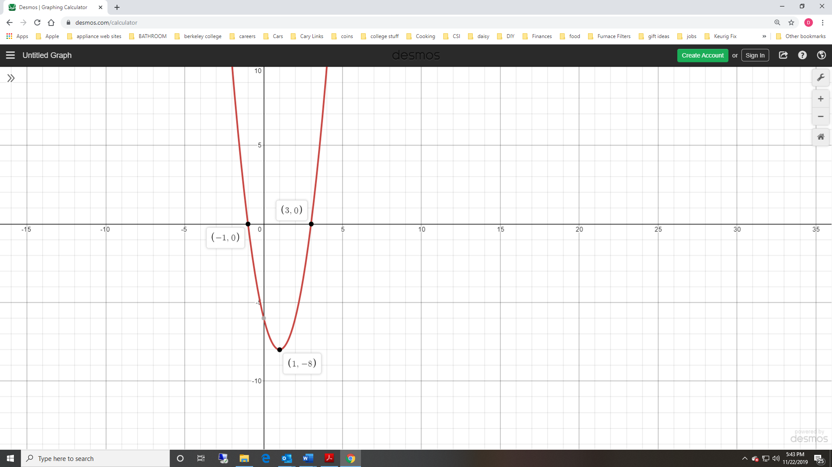

1. Consider the function $y=f\left(x\right)=x^{3}$.
2. Write a formula for the function produced when f is stretched by a factor of 3 and then shifted down by 2 units. Call this new function F and sketch its graph.
3. What function do you get is you reverse the order of the two operations in part a) and first shift f(x) down by 2 units and the stretch it by a factor of 3? Call this new function G and sketch it.
4. What is F-G?
5. Find the roots of the equation $x^{2}+2x+10=0$ and then use those solutions to factor the function $f\left(x\right)= x^{2}+2x+10$.